Employee Table (I m using Oracle and Sql Developer Client)
- CREATE TABLE Statement

CREATE TABLE Employee
(
EmpNo varchar2(8) CONSTRAINT EmpNoabsent null,
EmpName varchar2(50) CONSTRAINT EmpNameabsent not null,
Department varchar2(50) CONSTRAINT Departmentabsent not null,
Email varchar2(50) CONSTRAINT Emailabsent not null,
Phone varchar2(11) CONSTRAINT Phoneabsent not null,
CONSTRAINT empnoPK PRIMARY KEY (EmpNo)
);
- Run the above command
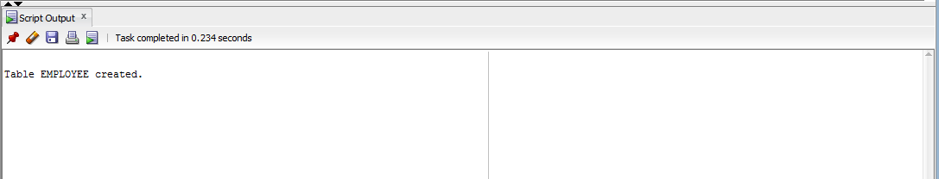
- Insert rows into it

- Table data
